Each folder is named to match the corresponding Figure/Table from the publication.

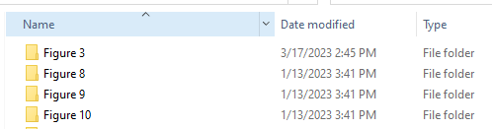

Within each compressed folder, there is one subfolder named config0001 along with two .cvs files.  The subfolder config0001 contains four files.

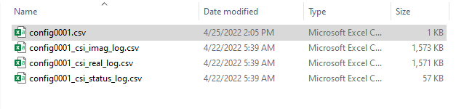

The **config0001.cvs** file describes the test condition; the test condition file is pointed out below. Within the test condition file are the test settings shown below:

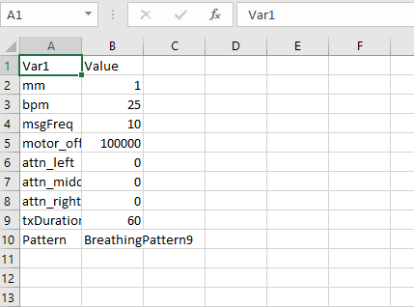

Important parameters are:

mm - the total mm that the linear axis was moving back and forth, acceptable values 1-5

bpm - the rate that the manikin was breathing (breaths per minute)

msgFreq - the frame rate that the CSI data was being transmitted, i.e., 10 frames/s

motor_offset – the absolute position of the motor when it starts moving back and forth

attn_left,_middle,_right –the attenuation (dB) of three transmitter antennas

txDuration – the amount of time that we are transmitting data, i.e., 60 seconds.

Pattern- the breathing pattern number

**config0001_csi_imag_log.csv** and **config0001_csi_real_log.csv** files contain 600*1026 imaginary and real values of channel state information data.

Each 802.11n Wi-Fi frame is either transmitted over either 56 subcarriers (when transmitting on 20 MHz) or 114 subcarriers (when transmitting on 40 MHz). Our routers support the transmission with three transmitting antennas and three receiving antennas. For each frame received at the receiver, the receiver observes a maximum of 3*3*114 = 1026 CSI estimates; that is why there are 1026 columns in the CSI matrix. Accordingly, the rows represent observations of CSI at a given time instance. This data was collected by sending 10 Wi-Fi frames every second for 60 seconds leading to 600 array rows.

It is possible to use less than the maximum number of subcarriers (by sending over a 20 MHz channel instead of 40 MHz) or the maximum number of antennas (by selecting an MCS supporting one spatial stream, for example). In that case, the corresponding CSI elements will be zeros. That is why some of the columns in the provided example data are zeros.

**Classification types:**

* **Breathing Rate:** Normal breathing pattern while the BR changes from 3 BPM to 30 BPM. We treat increments of BPM, i.e., from 3 to 30, as separate classes.
* **Breathing Pattern:** 9 different breathing patterns with different BPMs and Tidal volumes as specified in Table 1.

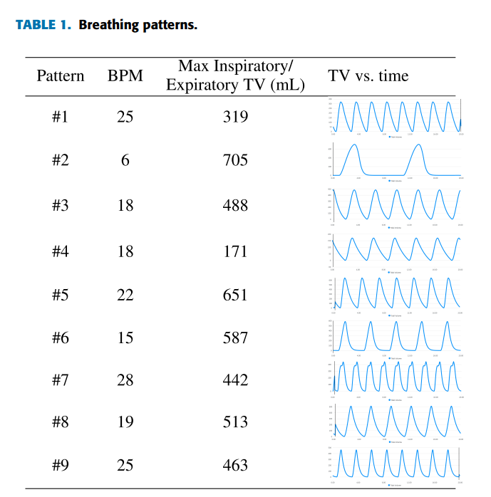

**Figure 3:** demonstrates the (a) complex values of the CSI data stream of a normal breathing pattern with a respiratory rate of 15 BPM, (b) the CSI data in the time domain (amplitude (unitless) vs. time (seconds)), and (C) CSI in the frequency domain (amplitude (unitless) vs. time (seconds)).

**Figure 8:** showsthe heat map of the normalized confusion matrix for Breathing rate classification (ranging from 3 BPM to 30 BPM) while there is no attenuation. Each class corresponds to a respiratory rate. Each cell (i, j) represents the probability of the class j label being predicted as class i. The lighter the red color, the smaller the misclassification rate. The results indicate that when a line-of-sight path is utilized between the transmitter and receiver, 99.97% of the Wi-Fi CSI data streams are correctly assigned to the corresponding respiratory rates, while 0.03% of respiratory rate predictions based on CSI are incorrect. The misclassified predictions happen at (30, 12) and (15,27).

**Figure 9:** demonstrates the confusion matrix —for 1-fold of cross-validation— of the pattern classification problem for 9 distinct patterns and a perfect scenario in which a line-of-sight path between the manikin and the monitor is available, and each breathing pattern was held for 60 seconds while data were collected. The measurements belonging to all breathing patterns are classified correctly when zero additional path loss is added to the measurement circuit. Diagonal elements of the confusion matrix show the number and percentage of correct classifications by the proposed BreatheSmart algorithm.

**Figure 10:** demonstrates how attenuation (distance) impacts the complex CSI data streams and the respiratory information of a normal breathing pattern with a respiratory rate of 15 BPM.

**Figures 11 (a)** and **(b):** show the heat map of the normalized confusion matrix (each element of this matrix is rounded to the nearest integer) for the scenarios in which the transmitter is at an equivalent distance of 23 and 72.76 meters away from the receiver, respectively. For attenuation loss of 20 dB (equivalently the transmitter is 23 meters away from the receiver), all respiratory patterns are very well classified with above 99% correct classification. As we artificially increase the distance between the transmitter and receiver, things get more complicated as at high attenuation most breathing patterns look alike. Therefore, the ability of the algorithm to accurately classify each respiratory pattern motion drops to above 78% for all classes.

**Figure 12:** demonstrates the heat map of the normalized confusion matrix for pattern classification and shows how increasing the amount of training data improves the performance of the classifier (compared to Figure 11 (b)). We acquired more data (double data set) and observed that overall pattern classification accuracy went up from 85.02% to 97.09% with (96.39%, and 97.79%) of the standard deviation of the overall classifier model accuracy using the 10 folds for cross-validation. Moreover, the ability of the algorithm to accurately classify each respiratory motion goes up from about 78% to about 95% for all classes.

**Figure 13:** demonstrates the PDF estimation of attenuated Wi-Fi CSI data streams based on a normal Kernel function. Each line represents the PDF of Wi-Fi CSI amplitude values (unitless) at a given attenuation value.

**Table 3**: shows the attenuation/distance effect on the respiratory pattern classification accuracy, for nine distinct respiratory patterns as discussed in Table 1.

**Table 4**: shows the attenuation/distance effect on the respiratory pattern classification accuracy, for normal breathing pattern (pattern#6) vs. abnormal breathing pattern (pattern numbers 1-9 except 5) as specified in Table 1.

**Table 5**: shows the attenuation/distance effect on the respiratory rate classification accuracy, for 28 different classes, respiratory rates change from 3 BPM to 30 BPM.

**Table 6**: shows the impact of the CST stream’s length on the respiratory pattern classification’s accuracy for 9 breathing patterns as specified in Table 1 and for attenuation loss of 20 dB.

**Table 7**: shows the impact of the CST stream’s length on the respiratory rate classification’s accuracy for 28 different breathing rates, ranging from 3 dB to 30 dB, and for attenuation loss of 20 dB.

**Table 8**: shows the Wi-Fi frame rate (frame/seconds) effect on the respiratory pattern classification’s accuracy of 9 different patterns as discussed in Table 1 for attenuation loss of 0 dB.